Sequential Datatype in Python
1. List
- Definition: A list is used to store a sequence of items. Lists can contain any type of data (e.g., integers, strings, or even other lists).
- Syntax: Lists are created using square brackets [].
- Properties:
  - Ordered: Lists maintain the order of items. Each item has a defined index.
  - Mutable: Items in a list can be modified after creation.
  - Allows Duplicates: Lists can contain duplicate values.
Examples

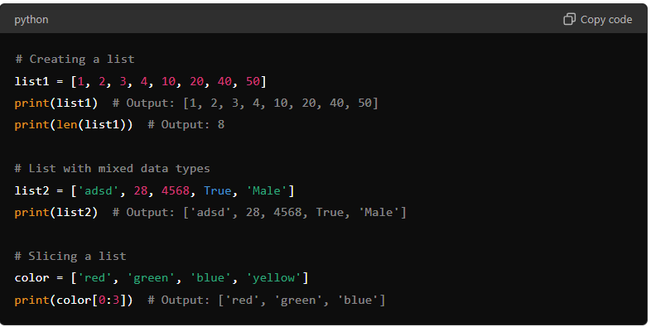
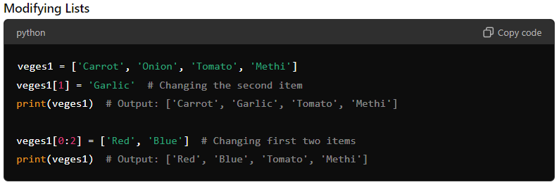

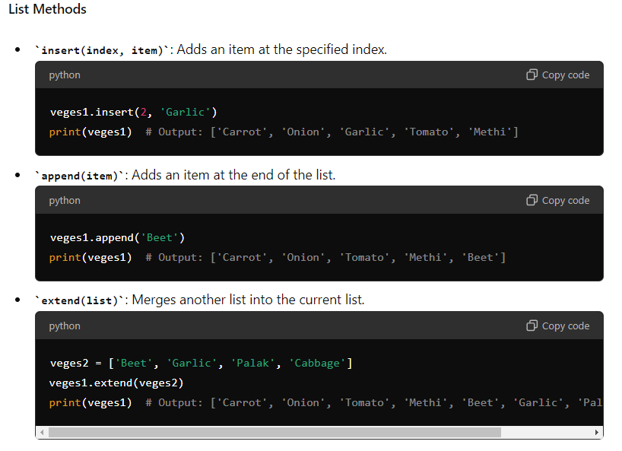
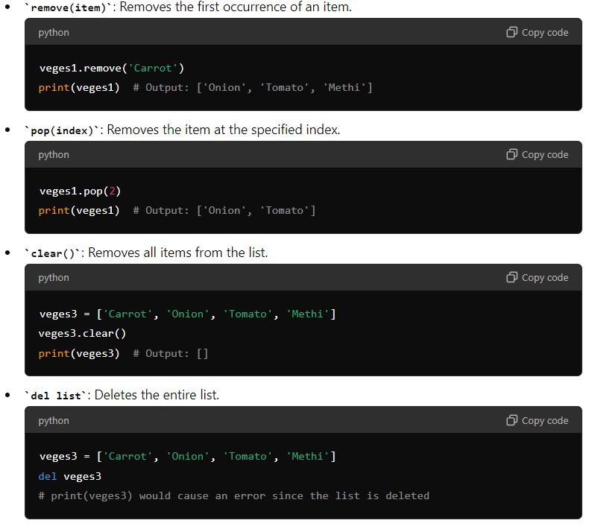

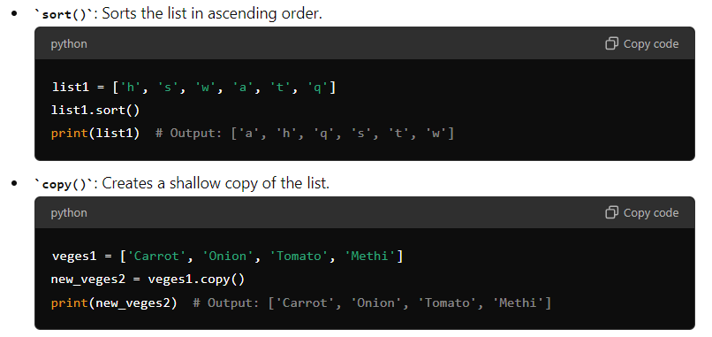

2. Tuple
- Definition: A tuple is similar to a list but is immutable, meaning once it's created, it cannot be changed.
- Syntax: Tuples are created using parentheses ().
- Properties:
  - Ordered: Tuples maintain the order of items.
  - Immutable: Once a tuple is created, its items cannot be modified.
  - Allows Duplicates: Tuples can contain duplicate values.
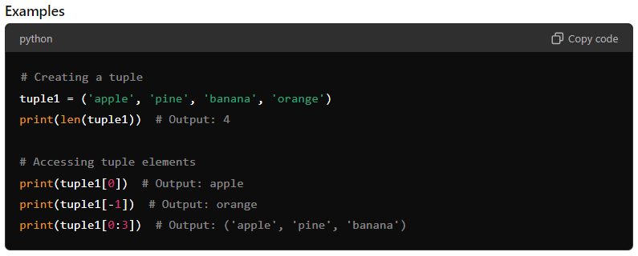

Modifying Tuples
Although tuples are immutable, you can convert them to a list, modify the list, and then convert it back to a tuple.
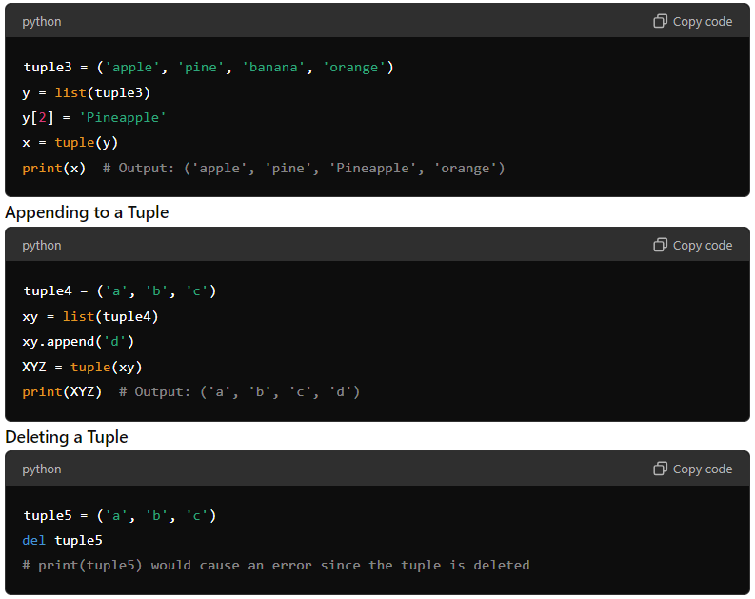
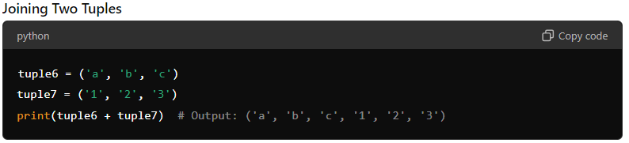

3. Set
- Definition: A set is used to store multiple items in a single variable. It is unordered, unindexed, and does not allow duplicate values.
- Syntax: Sets are created using curly braces {}.
- Properties:
  - Unordered: Sets do not maintain any specific order.
  - Unchangeable: Individual items in a set cannot be modified directly, but you can add or remove items.
  - Unindexed: Items in a set cannot be accessed by index.
  - No Duplicates: Sets do not allow duplicate values.
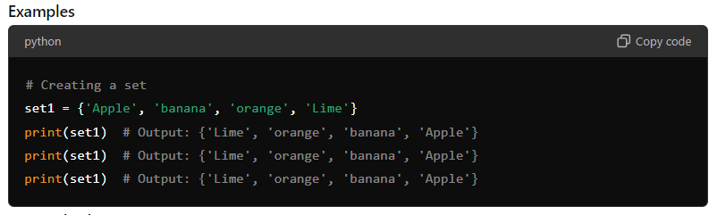
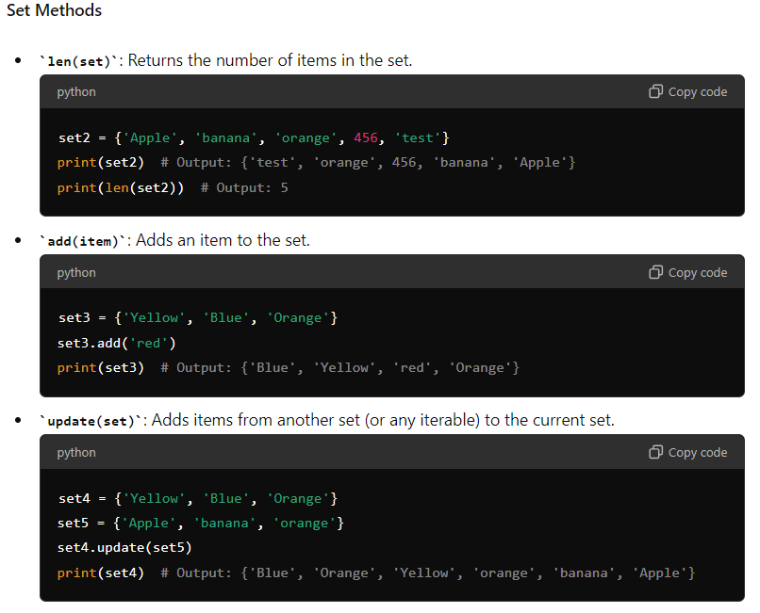
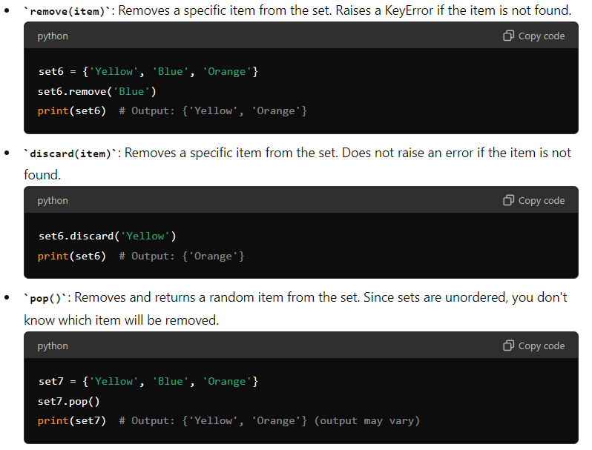
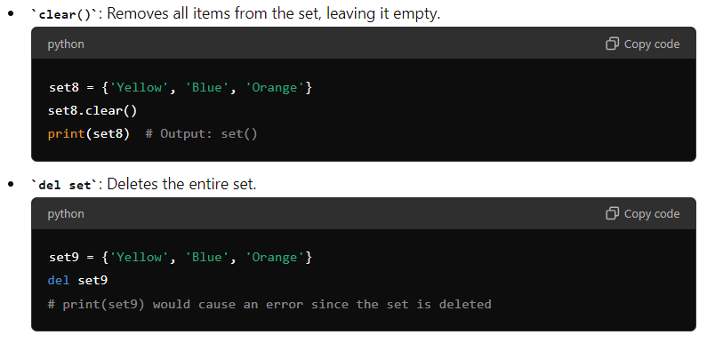
4. Dictionary
- Definition: A dictionary is used to store data in key-value pairs. It is mutable and can store data of any type.
- Syntax: Dictionaries are created using curly braces {} with key-value pairs separated by a colon :.
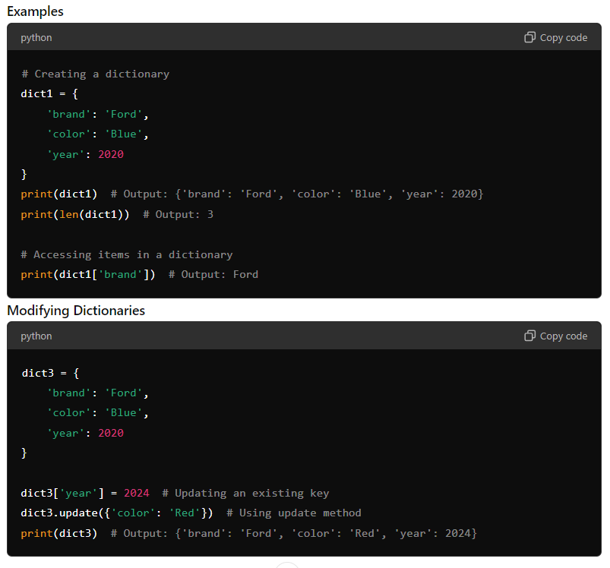
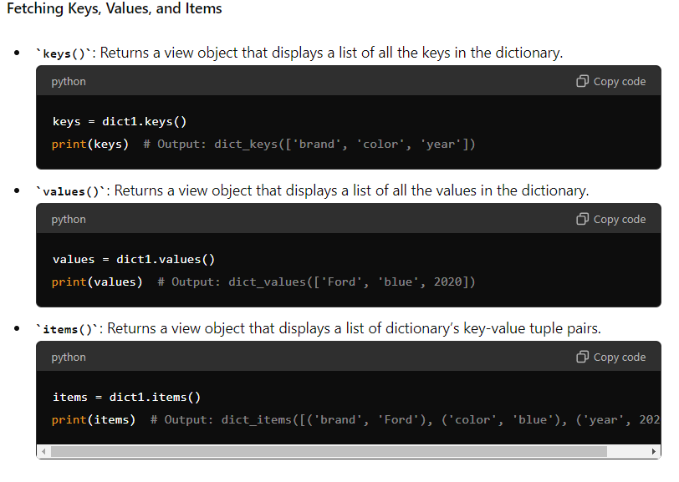
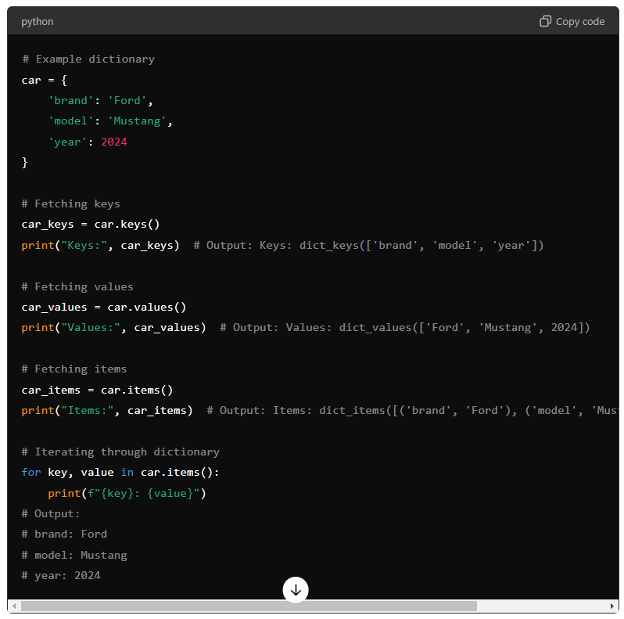
These examples demonstrate how to fetch and print keys, values, and key-value pairs from a dictionary, along with iterating through the dictionary to print all items.

